- How does multicollinearity affect linear regression?

- How do you interpret the residual vs fitted value curve?

- How do you interpret a linear regression model?

- Explain the bias-variance trade-off.

- Describe a well-known law or natural phenomena that you could model with linear regression.

- Is it necessary to visualize the data when you have fitted a line?

- Is linear regression suitable for time series analysis?

- Can linear regression be used for representing quadratic equations?

- Is Overfitting a possibility with linear regression?

- What is scaling? When is it necessary?

Solutions:
- Multicollinearity occurs when some of the independent variables are highly correlated (positively or negatively) with each other. This multicollinearity causes a problem as it is against the basic assumption of linear regression. The presence of multicollinearity does not affect the predictive capability of the model. So, if you just want predictions, the presence of multicollinearity does not affect your output. One of the major problems caused by multicollinearity is that it leads to incorrect interpretations and provides wrong insights. The coefficients of linear regression suggest the mean change in the target value if a feature is changed by one unit. So, if multicollinearity exists, this does not hold true as changing one feature will lead to changes in the correlated variable and consequent changes in the target variable. This leads to wrong insights and can produce hazardous results for a business.
- The residual vs fitted value plot is used to see whether the predicted values and residuals have a correlation or not. If the residuals are distributed normally, with a mean around the fitted value and a constant variance, our model is working fine; otherwise, there is some issue with the model. The most common problem that can be found when training the model over a large range of a dataset is heteroscedasticity(this is explained in the answer below). The presence of heteroscedasticity can be easily seen by plotting the residual vs fitted value curve.
- A linear regression model is quite easy to interpret. The model is of the following form:
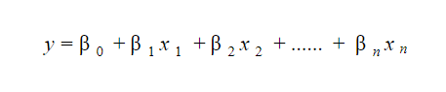
The significance of this model lies in the fact that one can easily interpret and understand the marginal changes and their consequences. For example, if the value of x0 increases by 1 unit, keeping other variables constant, the total increase in the value of y will be βi. Mathematically, the intercept term (β0) is the response when all the predictor terms are set to zero or not considered.
- Bias refers to the difference between the values predicted by the model and the real values. It is an error. One of the goals of an ML algorithm is to have a low bias.
Variance refers to the sensitivity of the model to small fluctuations in the training dataset. Another goal of an ML algorithm is to have low variance.
For a dataset that is not exactly linear, it is not possible to have both bias and variance low at the same time. A straight line model will have low variance but high bias, whereas a high-degree polynomial will have low bias but high variance.
There is no escaping the relationship between bias and variance in machine learning.
- Decreasing the bias increases the variance.
- Decreasing the variance increases the bias.
So, there is a trade-off between the two; the ML specialist has to decide, based on the assigned problem, how much bias and variance can be tolerated. Based on this, the final model is built.
- Many common laws have proportional relations and can be described by linear relationships. These can therefore be modeled with linear regression. A few famous examples are Ohm's law-related by V=IR or Newton's second law given by F=ma. On close observation, it is apparent that each of these laws has the form y=mx+c where c=0, or are essentially described by lines that pass through the origin.

- It is crucial to visualize the data when you fit a line because numerically fitting a line is easy with pure numerical analysis or methods like Least Squares regression. But determining whether these fitted lines make any sense requires further analysis of which visualizing the data is one of the easiest ways.
To underscore this point, let us consider Anscombe's quartet, the four datasets with almost identical simple statistical properties but appear wildly different in distribution when plotted.
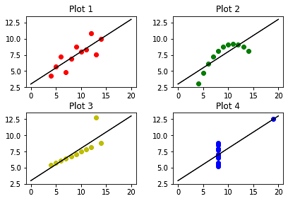
These four datasets result in a regression line with a slope of 0.50 and an intercept of 3.00. However, on plotting this line with the datasets, it becomes apparent that although fitted for datasets with almost identical results through quantitative analysis, the resultant line does not make any sense.
- While linear regression can be used for time series analysis and generally yield workable results, the performance is not particularly remarkable. The two main factors for this are:
- Time series generally have seasonal or periodic trends (such as peak seasons or even peak hours), which might be treated as outliers in linear regression and hence not appropriately accounted for.
- Future prediction is a generally sought-after use case in time series analysis, which will require extrapolation and rarely results in good predictions.
ARIMA, ARCH, and LSTM are widely used and better performing algorithms for time series analysis.
- Yes, paradoxically, a multiple linear regression model can be used to represent quadratic equations. For more complex linear regression models, we use multiple independent variables to predict the dependent variable. Such a linear regression model is called a multiple linear regression model.
A linear model with multiple dependent variables x1, x2, ..., xn can be written as
y=1x1+2x2+...+nxn.
For a quadratic function given by, say, y=ax2+bx+c, we can use x1=x2, x2=x, and x3=1, effectively representing the desired quadratic equation. Similarly, linear regression models can be used to describe higher-order polynomials as well.
- Yes, Overfitting is possible even with linear regression. This happens when multiple linear regression is used to fit an extremely high-degree polynomial. When the parameters of such a model are learned, they will fit too closely to the training data, fitting even the noise, and thereby fail to generalize on test data.
- The technique to standardize the features in the data set to fit within a fixed range is called Feature Scaling. It is performed during the preprocessing stage and helps avoid the dominance of certain features due to high magnitudes.
When using the analytical solution for Ordinary Least Square, feature scaling is almost useless. However, when using gradient descent as an optimization technique, the data scaling results can be valuable. It can help to ensure that the gradient descent moves smoothly towards the global minimum and that the gradient descent steps update at the same rate for all the features.

